**DAILY ONLINE ACTIVITIES SUMMARY**

|  |  |  |  |  |  |  |  |  |
| --- | --- | --- | --- | --- | --- | --- | --- | --- |
| **Date:** | **12-06-2020** | | | | | **Name:** | **Rani M.D** | |
| **Sem & Sec** | **VI B** | | | | | **USN:** | **4AL17CS075** | |
| **Online Test Summary** | | | | | | | | |
| **Subject** | | **No test** | | | | | | |
| **Max. Marks** | | **-** | | **Score** | | | **-** | |
| **Certification Course Summary** | | | | | | | | |
| **Course** | **TCS Carrier Edge** | | | | | | | |
| **Certificate Provider** | | | **TCS** | | **Duration** | | | **15 days** |
| **Coding Challenges** | | | | | | | | |
| **Problem Statement:**  1.Python program to find product of two arrays and count number of zeros in that array if any  2. Python program to Count the Number of Vowels Present in a String using Sets | | | | | | | | |
| **Status: Completed** | | | | | | | | |
| **Uploaded the report in GitHub** | | | | | **Yes** | | | |
| **If yes Repository name** | | | | | Daily Status | | | |
| **Uploaded the report in slack** | | | | | **Yes** | | | |

**Online Certification Details**

**1.**

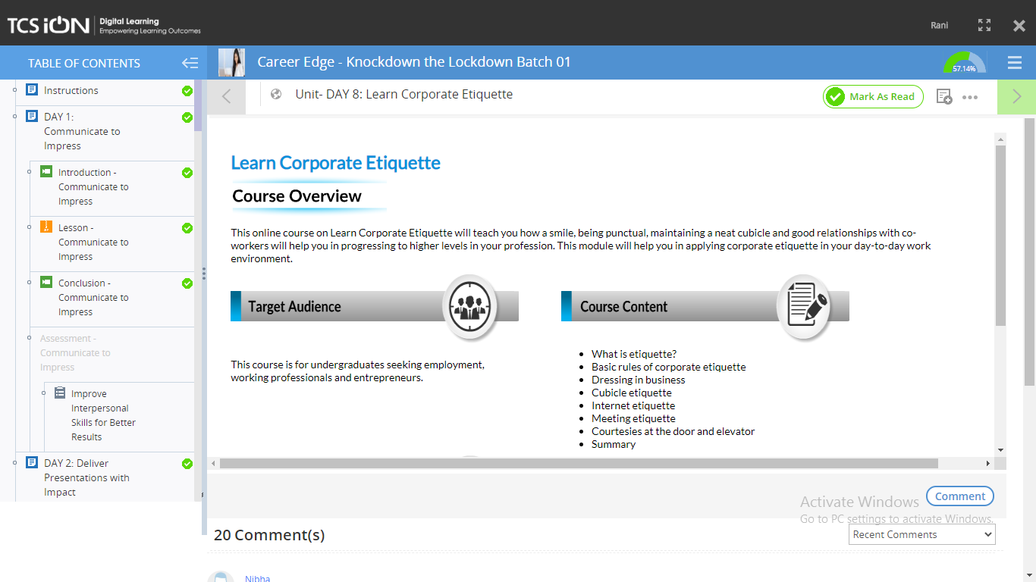

**2**



**3**

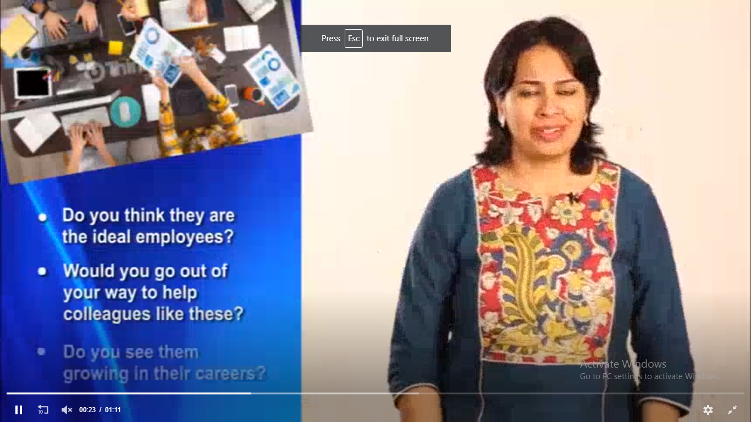

**4.**

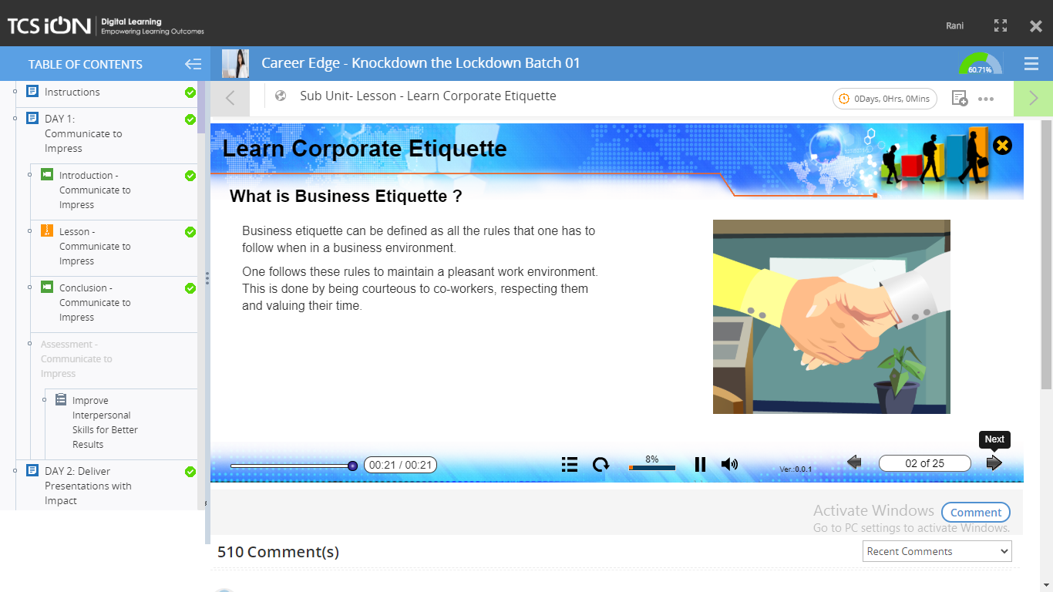

**5.**

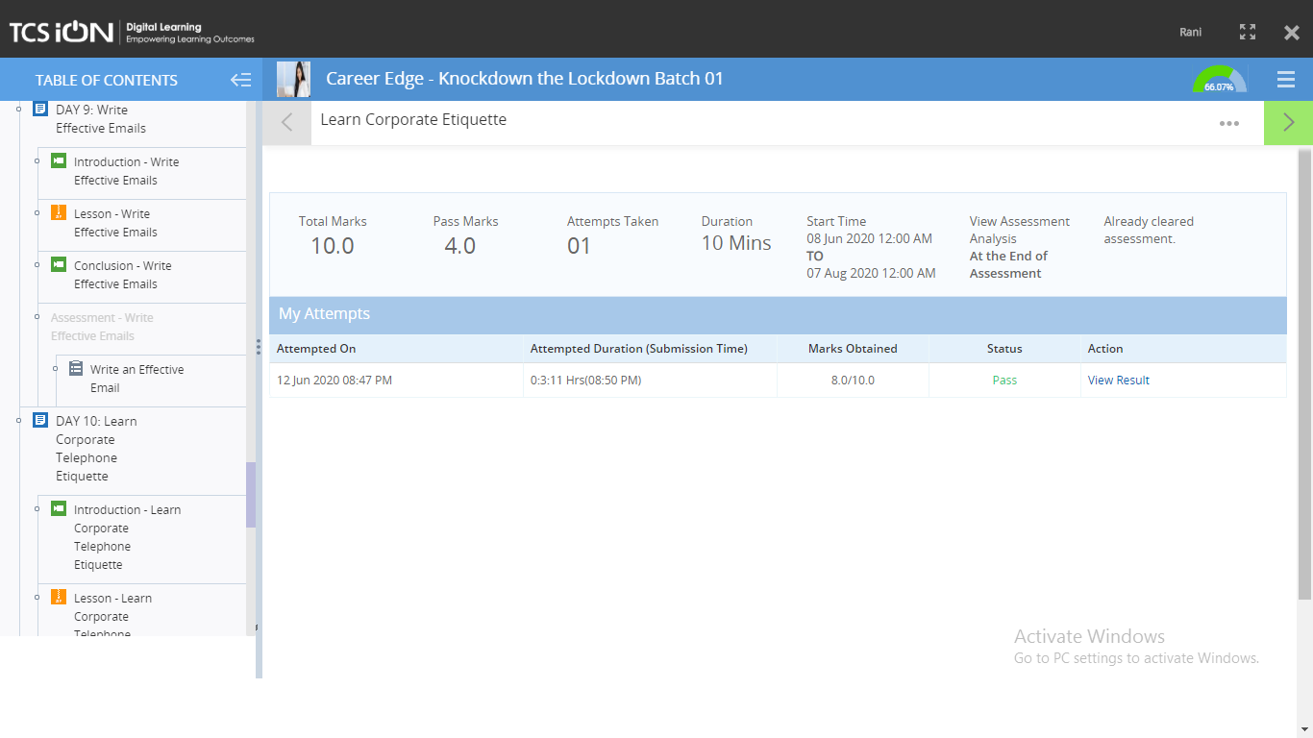

**Coding Challenge Details**

1. Python program to find product of two arrays and count number of zeros in that array if any

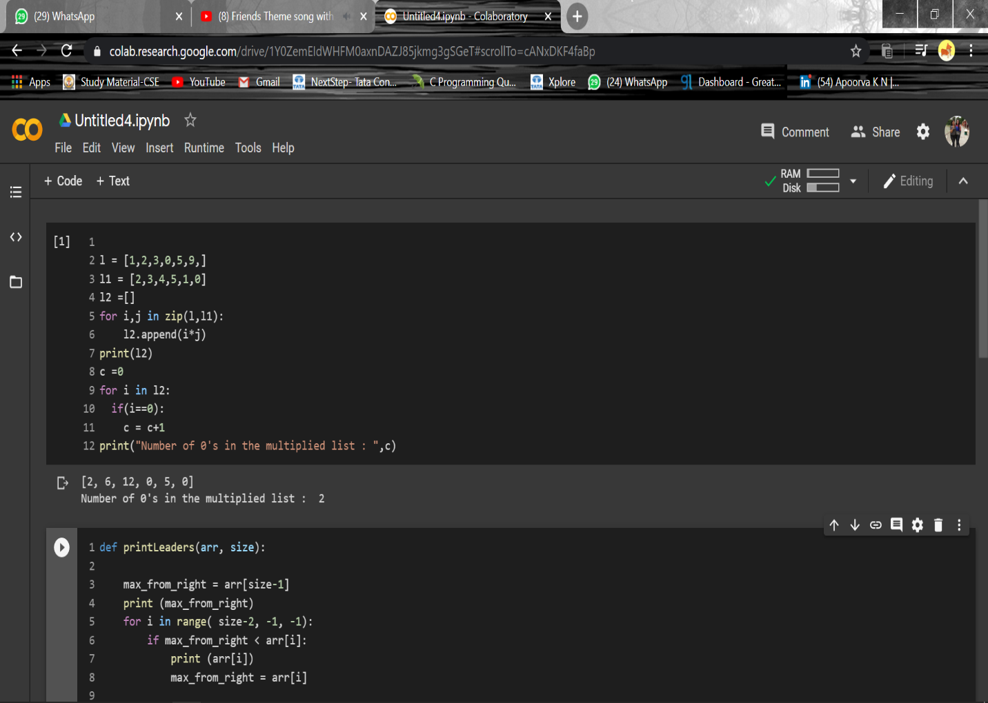

2. Python program to Count the Number of Vowels Present in a String using Sets

